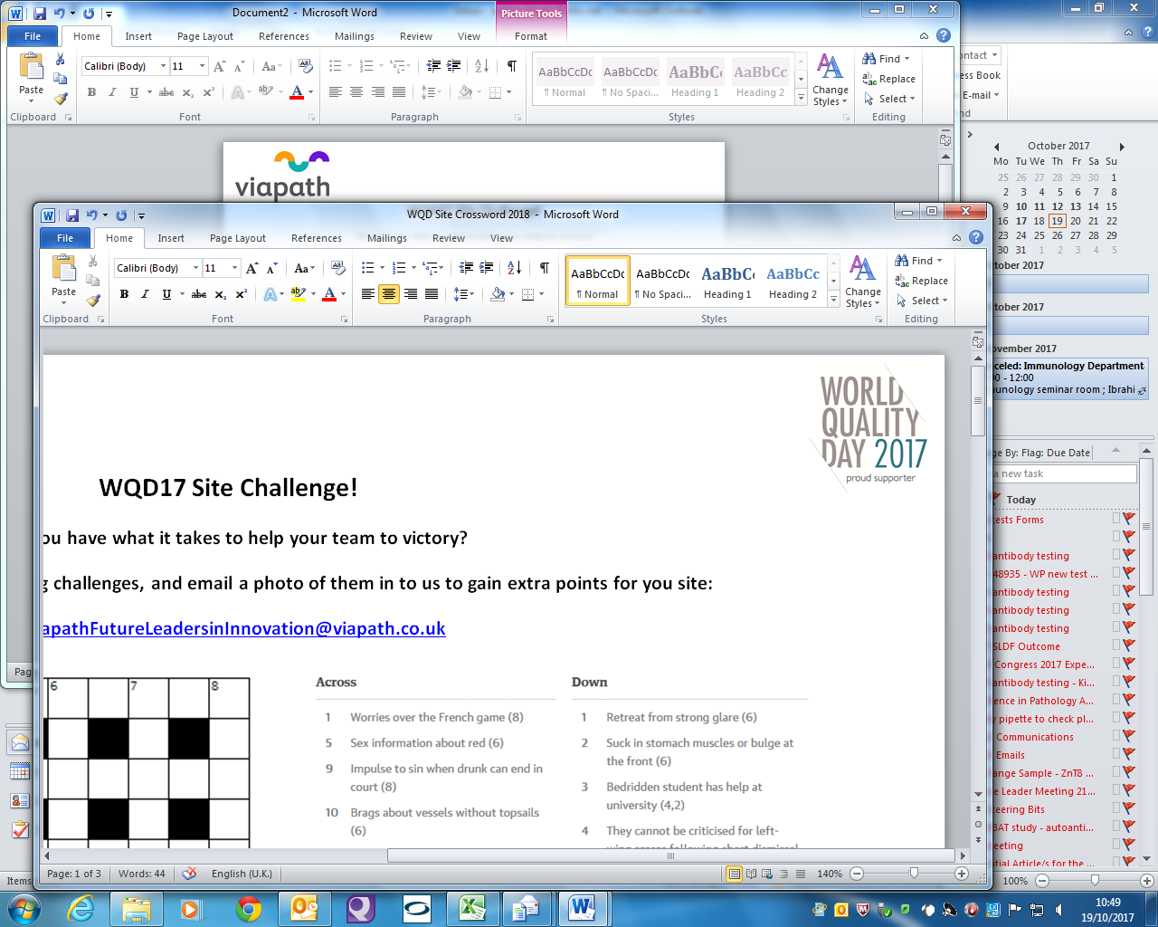** WQD17 Site Challenge!** 

**Do you have what it takes to help your team to victory?Can you make it down the ladder changing one letter at a time?**



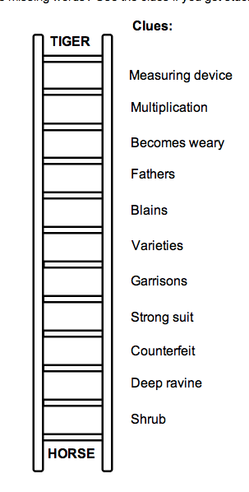

Top to bottom:TIGER,TIMER,TIMES,TIRES,SIRES,SORES,SORTS,FORTS,FORTE,FORGE,GORGE,GORSE,HORSE

**Completed crossword puzzle**

