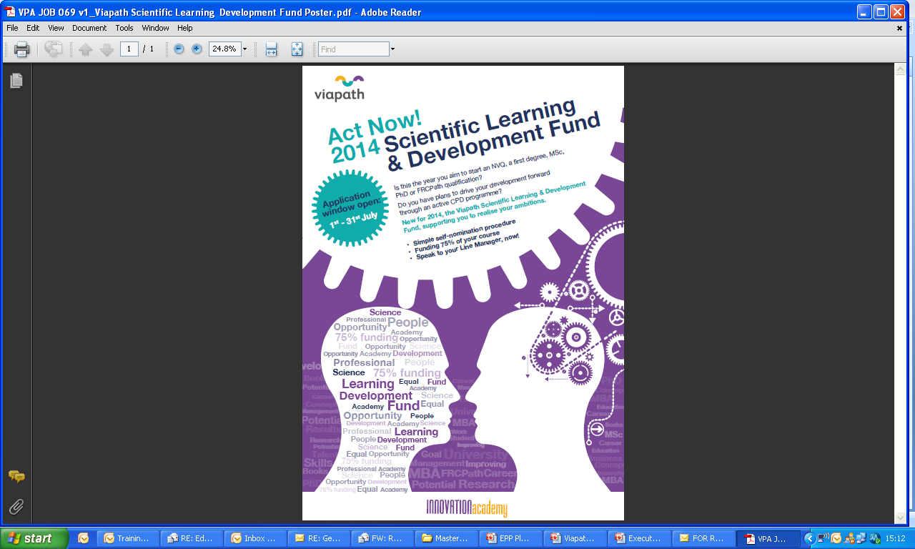

**Scientific Learning and Development Fund**

**Example courses by job role**

|  |  |  |  |  |  |  |  |
| --- | --- | --- | --- | --- | --- | --- | --- |
| Course | Assistant Technical Officer | Medical Laboratory Assistant | Senior Assistant Technical Officer | Biomedical Scientist | Clinical Scientist | Senior Biomedical Scientist | Senior Clinical Scientist |
| Foundation Degree |  |  |  |  |  |  |  |
| FRC Path 1 |  |  |  |  |  |  |  |
| FRC Path 2 |  |  |  |  |  |  |  |
| IBMS Cert of Achievement |  |  |  |  |  |  |  |
| IBMS Certificate Part 1 |  |  |  |  |  |  |  |
| IBMS Certificate Part 2 |  |  |  |  |  |  |  |
| IBMS Higher Specialist Diploma |  |  |  |  |  |  |  |
| IBMS Portfolio |  |  |  |  |  |  |  |
| IBMS Specialist Portfolio |  |  |  |  |  |  |  |
| MSc |  |  |  |  |  |  |  |
| MSc Online |  |  |  |  |  |  |  |
| MSc Project |  |  |  |  |  |  |  |
| Online short course |  |  |  |  |  |  |  |
| PG Cert |  |  |  |  |  |  |  |
| Professional Acknowledgement for Continuing Education (P.A.C.E) |  |  |  |  |  |  |  |
| Professional Doctorate |  |  |  |  |  |  |  |
| Short courses |  |  |  |  |  |  |  |
| Top Up Modules |  |  |  |  |  |  |  |

**Role**

|  |  |  |  |  |  |  |
| --- | --- | --- | --- | --- | --- | --- |
| **Course** | **MLA / ATO / SATO/ MTO** | **Biomedical Scientist** | **Senior Biomedical Scientist** | **Clinical Scientist** | **Senior Clinical Scientist** | **Ops / Service Delivery Manager** |
| **IBMS Certificate of Achievement Part 1** |  |  |  |  |  |  |
| **IBMS Certificate of Achievement Part 2** |  |  |  |  |  |  |
| **Foundation Degree** |  |  |  |  |  |  |
| **Top Up Modules** |  |  |  |  |  |  |
| **IBMS Portfolio** |  |  |  |  |  |  |
| **IBMS Specialist Portfolio** |  |  |  |  |  |  |
| **IBMS Higher Specialist Diploma** |  |  |  |  |  |  |
| **PG Cert** |  |  |  |  |  |  |
| **Professional Acknowledgement for Continuing Education (P.A.C.E)** |  |  |  |  |  |  |
| **Online short course** |  |  |  |  |  |  |
| **Short courses** |  |  |  |  |  |  |
| **MSc** |  |  |  |  |  |  |
| **MSc Online Module** |  |  |  |  |  |  |
| **MSc Project** |  |  |  |  |  |  |
| **MBA** |  |  |  |  |  |  |
| **FRC Path 1** |  |  |  |  |  |  |
| **FRC Path 2** |  |  |  |  |  |  |
| **Doctorate in Biomedical Sciences** |  |  |  |  |  |  |